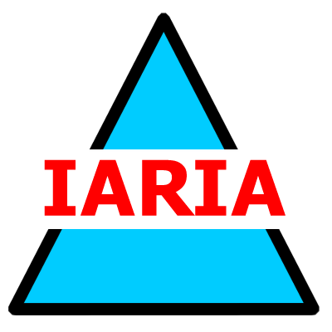 | International Academy, Research, and Industrial Association  PO Box 7827, Wilmington, DE 19803  Fax: +1-302-397-2009, email: sue@iaria.org  http://www.iaria.org

SPONSOR FORM

Our company is pleased to support the scientific activities of IARIA by a sponsorship grant at the level indicated below.

This sponsorship is for the conference _______________________________

Sponsoring company _____________________________________________

Contact name ___________________________________________________

Address ________________________________________________________

Phone _________________________ Fax ___________________________

Email __________________________________________________________

Please indicate the sponsorship level:

[ ] DIAMOND $25,000  [ ] PLATINUM $20,000  [ ] GOLD $15,000 | [ ] SILVER $10,000  [ ] BRONZE $5,000  [ ] SUPPORTER $2,500

Please choose the form of payment:

[ ] Check | [ ] Bank Transfer | [ ] Credit Card

If by credit card, provide this information:

Card number: _________________________________________________________
Expiration date: ___________

Holder's Name: ________________________ Holder’s Signature: _________________

Credit Card billing address:

Street address:________________________________________________________

City: _______________________________ State: ___________________________

Zipcode/Postcode _____________________ Country: ________________________

Contact information: sue@iaria.org fax: +1-302-397-2009

