MOOREA DAY TOUR FROM TAHITI
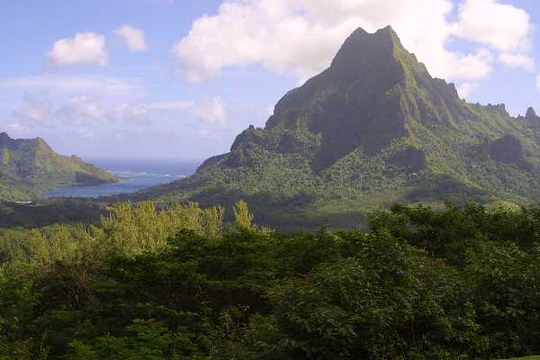
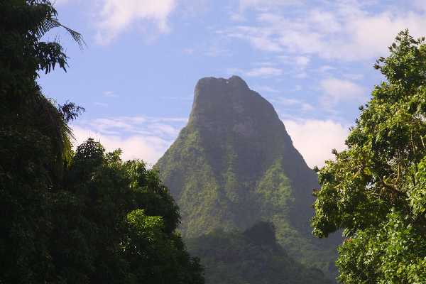
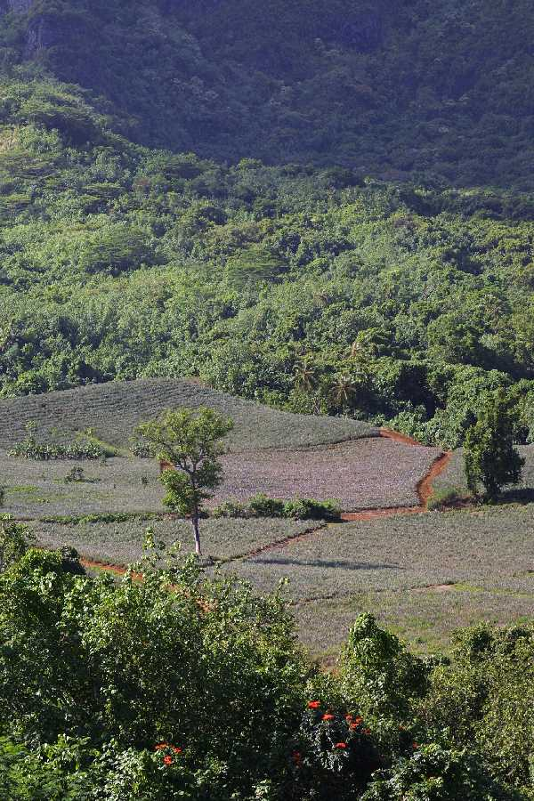
DETAILED ITINERARY
09h00 Departure from Tahiti by fast catamaran “Aremiti 5”
09h30 Arrival in Moorea and departure from the Pier by air conditioned bus to enjoy the beautiful secenary of Cook’s Bay - Opunohu Bay .
10h00 Stop at the Marae - Ancient Polynesian temple
10h15 Ascension to Le Belvedere look out point for a spectacular panoramic view over
the two famous bays forming a heart shape with the dramatic volcanic moutain
10h45 Drive down to the Agricultural School - (stop for toilets)
11h00 Visit the Moorea distillery and Fruit Juice Factory (free tasting) -
11h30 Arrive at the pier of Papetoai and embark on large and comfortable motorized catamaran This time, you will discover the magnificent island of MOOREA from the lagoon side .

13h00 Meet the rays and “BBQ” lunch on a private motu
15h00 return transfer by boat from the motu to the pier
15h30 Transfer by bus towards the ferry terminal (Vaiare dock)
16h45 Departure from Moorea by fast catamaran back to Papeete (30mn crossing)
Moorea Highlights by air conditioned bus
Enjoy a comfortable trip introducing all the major point of interest of the island of Moorea. Discover all about this charming island : history - culture - nature - tremendous view points … The most important you should know about this little paradise…
Lagoon discovery with Polynesian BBQ lunch on a private islet
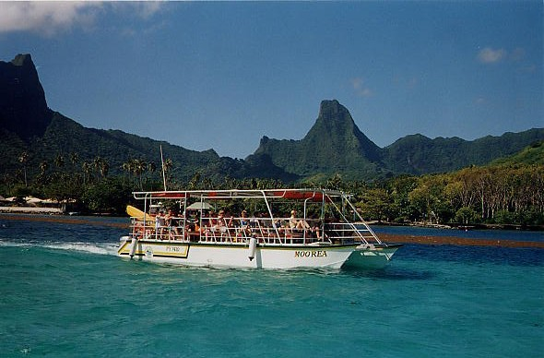
Depart from the pier in a covered boat that will protect you from the direct rays of the sun. The boat will take you first east wards to the legendary Cooks and Opunohu bays, where the crew will introduce some of the history and the myth of Moorea. According
to an ancient legend, these bays were created by a huge lizard with its tail.
The boat will take you to a “motu”, a gorgeous sandy islet surrounded by transparent turquoise waters, shallow enough to walk comfortably. As soon as the boat arrives, you find the rays waiting for you. In exchange for a piece of fish they will gracefully dance around you. No need to be a skilled diver to swim freely in the warm waters and enjoy this experience.
You will then enjoy lunch on a “motu” (small islet) will be prepared for you (mixed salads, BBQ fish or meat, fruits, soft drinks and beers included). During lunch, the guide will be playing nice Tahitian songs with guitars & ukulele and do a "coco" show and a "pareo" show.
After lunch relax on the motu till it’s time to get back to the pier

Important notes: Participants should be comfortable wearing snorkel equipment and being in deep water to cope with occasional currents. You may remain in the boat, but from there viewing will be limited. Not recommended for the disabled

